Ref. No: Date: 07/08/2023

Notice Regarding 4th Semester GE Internal exam
It is hereby notify to all students of 4th semester GE that an internal exam on CHEMGT - 2 will be held on 14/8/2023 at room no 304 at 11:15 am. all must come with pen and old admit card.

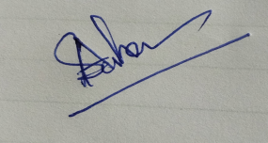
HOD
Department of Chemistry

